Exp 1 Design a LED Flasher

Circuit Daigram 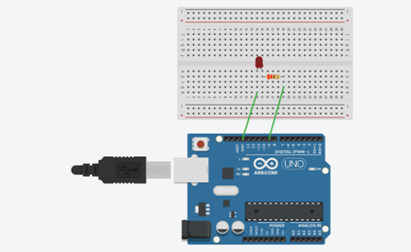

Theory

**Concepts used:**

1. The LED.

2. Connecting Arduino uno.

3. The code for program.

4. By using kirchoff’s voltage law.

5. By using kirchoff’s current law

**Learnings and Observations**

1. Basic circuit building with Arduino uno.

2. Interfacing an LED with Arduino uno.

Few observations are:

1. When the delay was changed from 1000ms to 200ms, the blinking of LED became faster but still observable that it turns on and off

2. When the delay was changed from 200ms to 60ms, then the LED does not blink further, it appears as it stays on because the changes at that speed can’t be detected by our eye.

• Connections in Breadboard and wiring.

• How to control arduino and its coding.

• Use of multimeter for continuity.

• Use of resistor to resist excess flow of current.

**Precaution**

1. The LED should not be connected in reversed direction (i.e. Observe negative and positive terminal before connecting LED).

**Learning outcomes**

1. The application and usage of digital input/output pins of Arduino uno.

2. The working of LEDs and their interfacing with Arduino Uno.

3. Understanding and writing the basic code in Arduino IDE.

4. On and off of an LED

5. Used in project works